ABOUT 20/20

Education 20/20 Inc. is an independent, broad based, national, not-for-profit education organization, located in Charlottetown, PEI and is governed by a volunteer Board of Directors.

Vision: A quality education for every Canadian.

Directors: Directors: Don Glendenning, President, Bill Whelan, Vice President, Tom White-Hassler, Katherine McQuaid, Donald DesRoches. Amber Jadis, Tess Miller, Ronnie McIntosh and Ross Reid

Our thanks
- Donors, volunteers and friends
- Don Glendenning, Editor
- Louise Carota, artist
- ??

Information including donations: www.education2020.ca

Sponsors:

Pub1/2018


Learner on the Road of Life by Louise Carota

ABOUT EDUCATION

Education 20/20 Inc.
101 Kent St., PO Box 624/rue Kent, BP 624
Charlottetown, PEI C1A 1M0 Canada
www.education2020.ca – pei@education2020.ca
2

THIS BOOKLET

Our future depends to a large degree on the nature and quality of our education; it behooves us, therefore, to make sure that education is a quality one. This booklet provides a framework, not a blueprint, for decision-making in the educational component of our lives.

Organizing and delivering education services is a complex matter given the variables - geography, culture, individual differences, ages, prior learning and personal interests. To this we must add the evolving world in which we find ourselves including a global reach, instant communication and artificial intelligence.

Canada has a long and enviable history of public education but public education is out of sync with the times. The milieu in which education operates is dramatically different from its roots as are the tools available to those who make it happen. A review and clarification of the framework is crucial. The release of this booklet is simply a step in the process.

The decision to release this in draft form is deliberate for two reasons, (1) because the shape of tomorrow’s model is still emerging and (2) you, the learner, will play the significant role in giving it form.

WATCH FOR EDITION 2

LEARNING PATH
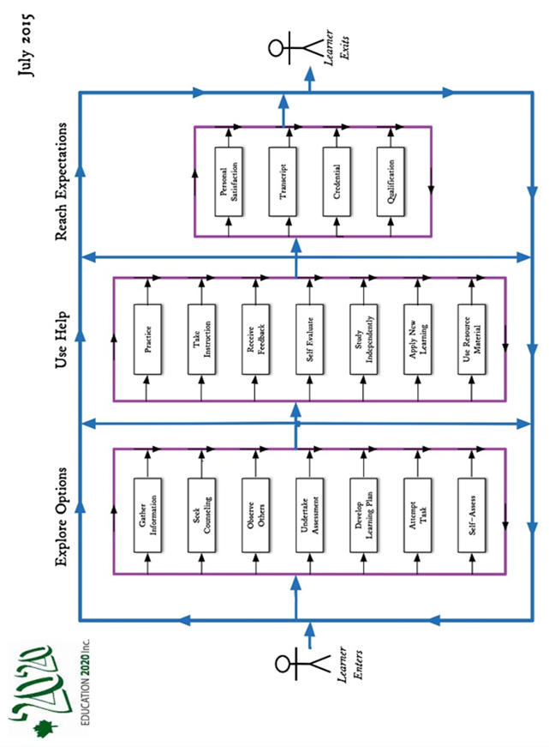

ROAD OF LIFE

We are all on the road of life. The road of life is a metaphor for the experiences we encounter between birth and death. While on the road, each person fills a number of roles, that of an
• individual,
• family member,
• citizen,
• student
• producer and
• consumer

HURDLES
The road of life, like any road, presents its share of hills, hollows twists and rough spots including:
• Need for formal qualifications
• Limits to our own learning
• Culture we carry with us and the culture we acquire
• Personal commitments and responsibilities

ESSENTIAL SKILLS
Some skills are considered essential for everyday living; while readers could make their own list, most lists would likely include the following:
• Communications
• Numeracy
• Community awareness
• Self-management
• Interpersonal relationships
• Information technology

TYPICAL EDUCATION SERVICES
Education system - services put in place by a community to encourage and support the education of its citizens These are considered typical functions or services of an education system

Information and Counselling
- Recent and independent information needed by Islanders in the making of decisions about their own education or the education of others
Governance and Leadership
- In the form of a body and organization with vision and responsibility to put in place and monitor educational services for the benefit of its citizens,
Instruction
- The provision of help to others in their learning that includes diagnosis, counselling, presentations, practice and access generally to resources
Quality Assurance
- A system that assures Islanders that their learning experiences, including providers of those services, meet community standards.
Products and Technology
- Access by Islanders to educational materials, technology and other resources to help learners develop skills needed to meet their responsibilities and objectives.
Funding
- Funding to a level and in a manner that is equitable for all Islanders.
Human Resources
- Teachers, administrators, counsellors, advisors. Assistants and other people who help other people learn
A FEW BELIEFS

- Education: Any experience that has a formative effect on the way a person thinks, feels or acts

- Educate – to broaden the range and increase the level of performance in a person’s skillset

- Education, purpose – to develop one’s capacities as participating member of a community or society

- Education system - services put in place by a community to encourage and support the education of its citizens

- Outcome - That which is produced or occurs as a result of an event or process

- Standard” a readily distinguishable level of performance, demonstrated though the making of a product or provision of a service which is deemed worthy of recognition

- School – an institution designed for students (or pupils) to learn under the direction of teachers

- Student – someone who attends an educational institution

- School system – institutions, programs and services provided and encouraged by or with the approval of a community through its government for the purpose of providing formal education for its residents

MANAGING THE LEARNING PROCESS
CRSP

OTHER
1. Bibliography
2. Leading edge sites
3. Education or public education
4. Providers
5. Gaps
6. Current
7. Donate now
8. Ancillary services: assessment, transportation
9. Qualifications
10 Citizens
Ground rules

TOMORROW …

- Education will organize services around needs of individuals; learning managers will direct learners to appropriate providers and monitor their progress
- Communities will be served service centers residents of all ages; education will be one of the services
- Certification of levels of achievement will be provided by independent qualification authorities
- Schools may continue to use grade levels for administrative purposes
- will provide a transcript only of student achievement.
- Separation of teaching and levels of achievement will result in increased lifelong learning
- Essential skills, including self-management, skills will be a more significant component of public schooling
- A rise in An education system will allow for independent clinics i.e. literacy, ADD, mathematics, etc. Educational clinics
- Curricula will be competency based and developed from common analysis of life roles and fields of service.

ISSUES
Issues are topics, problems or concerns of importance to groups of people; they are the big questions. Issues are not simple problems for which definitive answers can easily be found. On the contrary, they are complex and of significance. Once understood, the simpler questions can be dealt with and progress resumed.

- Ownership or accountability for actions taken and results achieved
- Degree of autonomy, especially of the professional educators, to make decisions regarding the best course of action for individual clients
- Absence of market forces or self-regulation that ensures some level
- Is compulsory schooling needed in 20/20?
- Relevance of learning experiences to life and life roles of learners
- Quality assurance in a government operated system
Standards
• Not community based
• Lack support for independent learning
• Static rating scales
• Benchmarks

Employment preparation
Delivery Model
• Inflexible
• Admin convenience
• Bureaucratic
• Time based
• Schooling not education Batch process

information
• Current
• Independent

TRANSITION: AN ALTERNATIVE

“A student’s ability to transition from secondary school to post-secondary education and the labour market is a key measure of the education system’s success for students” – CMEC, July 2016

LEARNERS AND LEARNING

A learner is a person who, for whatever reason, is trying to bring about change in his/her life - trying to change an attitude, gain new knowledge or add to their skills; but learners are neither empty jars nor blank slates; each learner carries three pieces of luggage to every new learning situation:
• Physical, mental and emotional conditions with which the l
earn was born.
• Prior learning
• Imagined futures

LEARNING
A process of engaging in experiences that have a formative effect on the way we think, feel or act

Our futures may benefit from or even require a different mix of attitudes, skills and knowledge than the ones we now have; the process of developing the new mix is called learning, the discernable change that occurs in us as a result of learning is called education

LEARNING MODEL/PATH
A person’s learning path is not a straight line. The learning path, on the page following, below was developed in consultation with a panel of postsecondary students who told us about their learning experiences. While school oriented, it presents the typical complexities of the flow of learning experiences.

DONATE NOW
Readers wishing to contribute to the improvement of education are invited to:
- Mail a contribution to the address shown on back page, or
- Use Canada Helps on our website, or
- Make a contribution in our name to the Community Foundation of Prince Edward Island

ABOUT EDUCATION

• Education: Any experience that has a formative effect
on the way a person thinks, feels or acts

• Educate – to broaden the range and increase the level of performance in a person’s skillset

• Education, purpose – to develop one’s capacities as participating member of a community or society

• Education system - services put in place by a community to encourage and support the education of its citizens

• Outcome - That which is produced or occurs as a result of an event or process

• Standard” a readily distinguishable level of performance, demonstrated though the making of a product or provision of a service which is deemed worthy of recognition

• School – an institution designed for students (or pupils) to learn under the direction of teachers

• Student – someone who attends an educational institution

• School system – institutions, programs and services provided and encouraged by or with the approval of a community through its government for the purpose of providing formal education for its residents

RATING SCALES*

Education providers use a variety of approaches to improving fairness and consistency when rating; most common are grids and check lists. Others are beginning to appear, most with frequently for individual subjects. Newer rating scales are beginning to appear and are usually less technical and give more weight to rater judgement. The scale shown below is promoted as being applicable to all school subjects.

Description | Score
Demonstrates complete understanding of the problem. All requirements of task are included in response | 5
Demonstrates considerable understanding of the problem. All requirements of task are included | 4
Demonstrates partial understanding of the problem. Most requirements of task are included | 3
Demonstrates little understanding of the problem. Many requirements of task are missing | 2
Demonstrates no understanding of the problem | 1
No response/task not attempted | 0
**Getvn.asp

